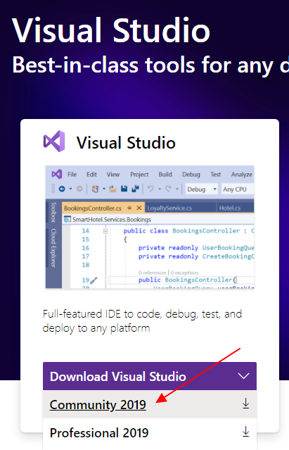

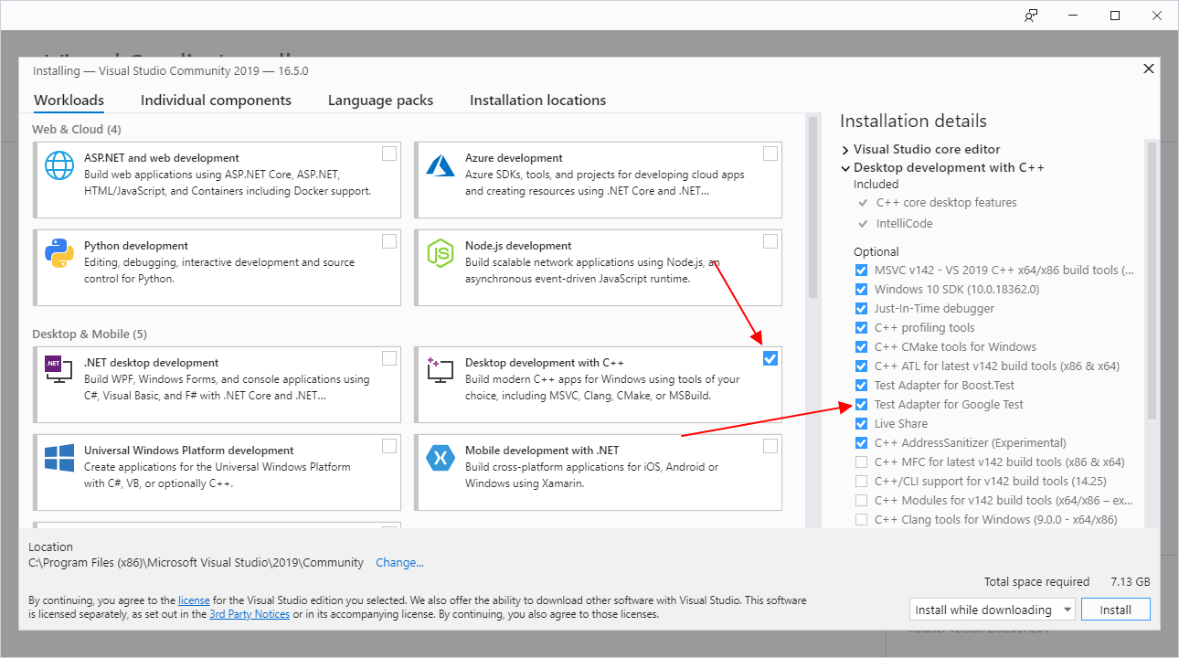

# Production Code Project

This project can be any C projects (including AVR Studio projects), but for the example it is made as a Visual Studio C project in a where a Test project will be added later on,

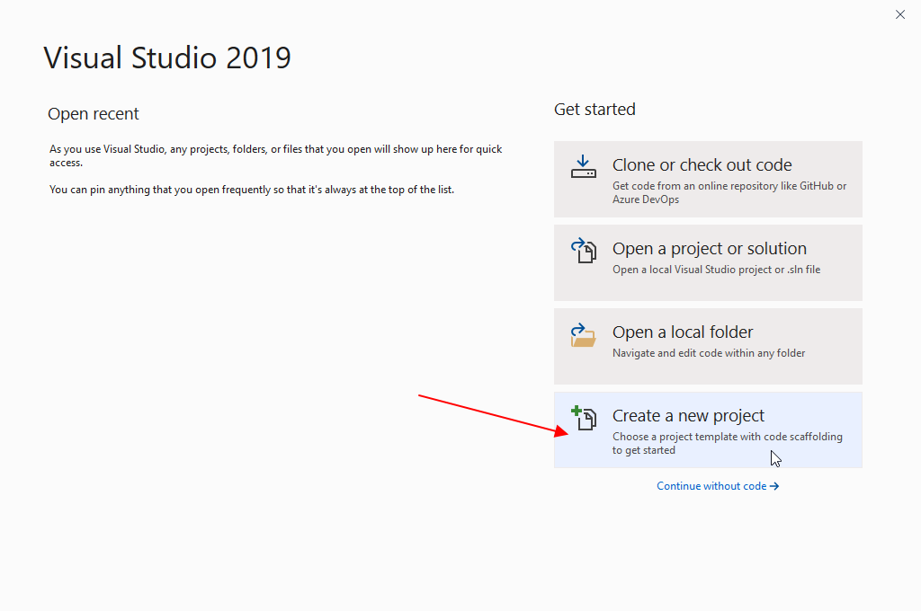

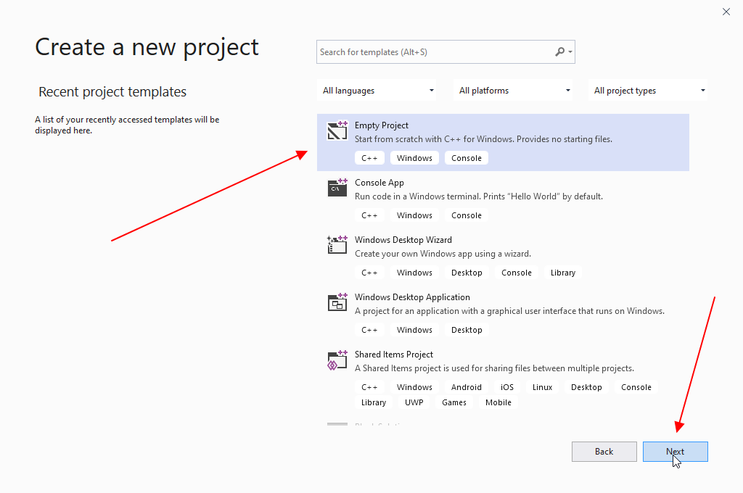

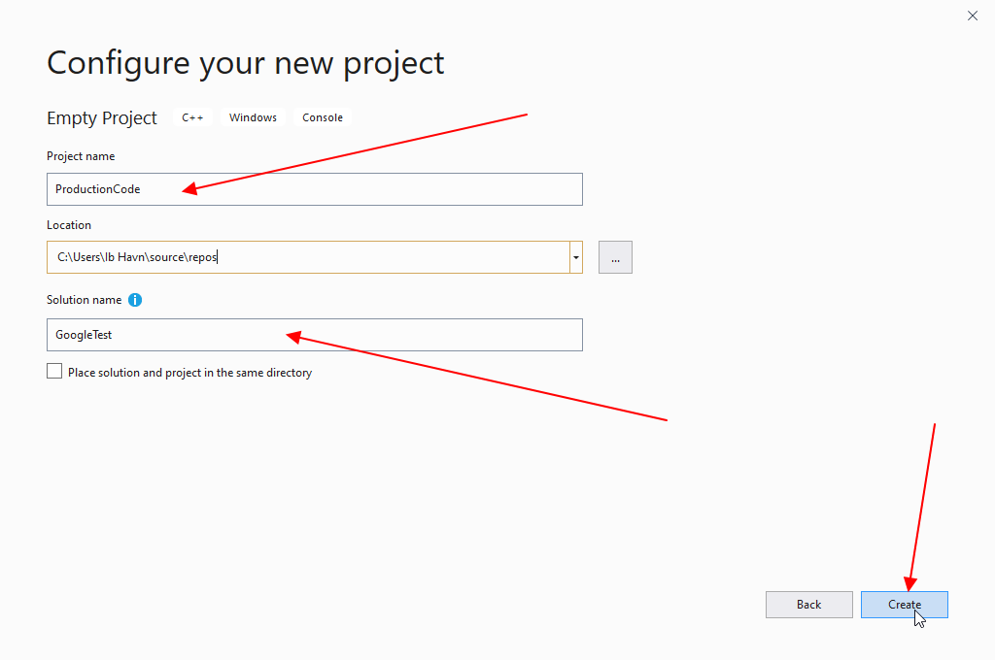

# The Test Project

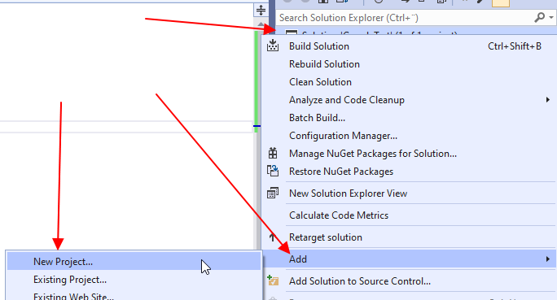

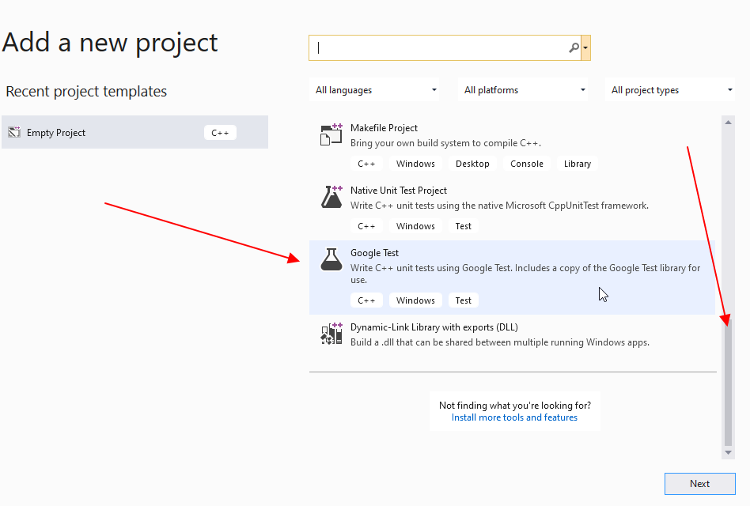

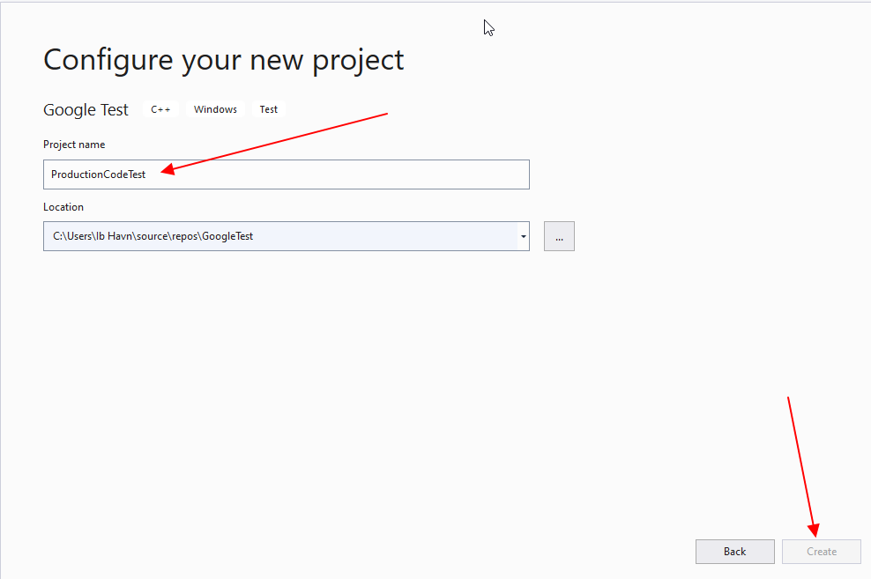

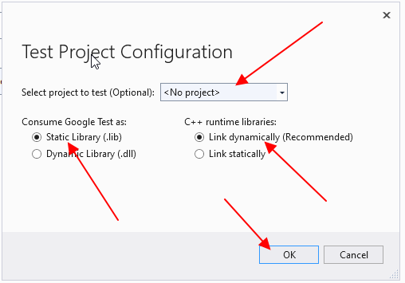

Right click on the test project (*ProductionCodeTest*) and *Set as Startup Project*.

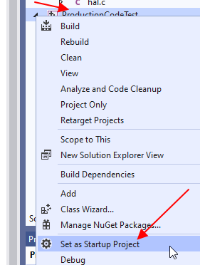

Right click on the test project (*ProductionCodeTest*) and *Properties*.

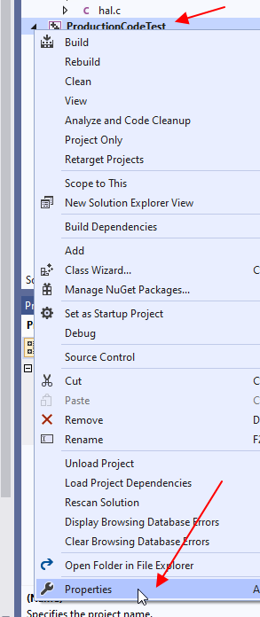

Rename *test.cpp* to *productionTest.cpp* to indicate that this test is testing then production code (*production.c*)

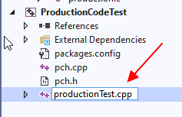

The test file looks like this now:

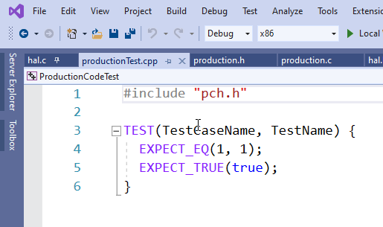

Change the contents by adding a Test fixture (*ProductionTest*) then we can have *SetUp()* and *TearDown()* functions.

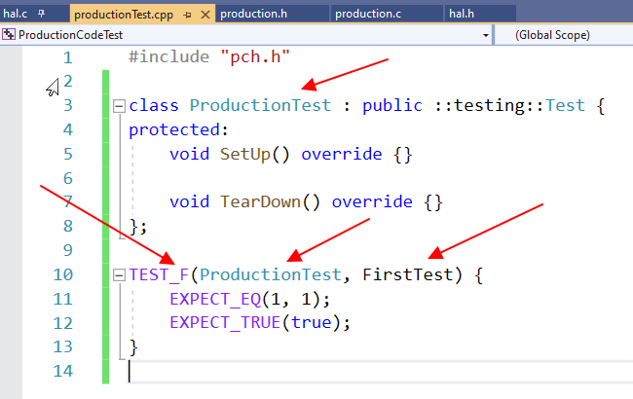

Try to run it (*ctrl+F5*) and you will see the result:

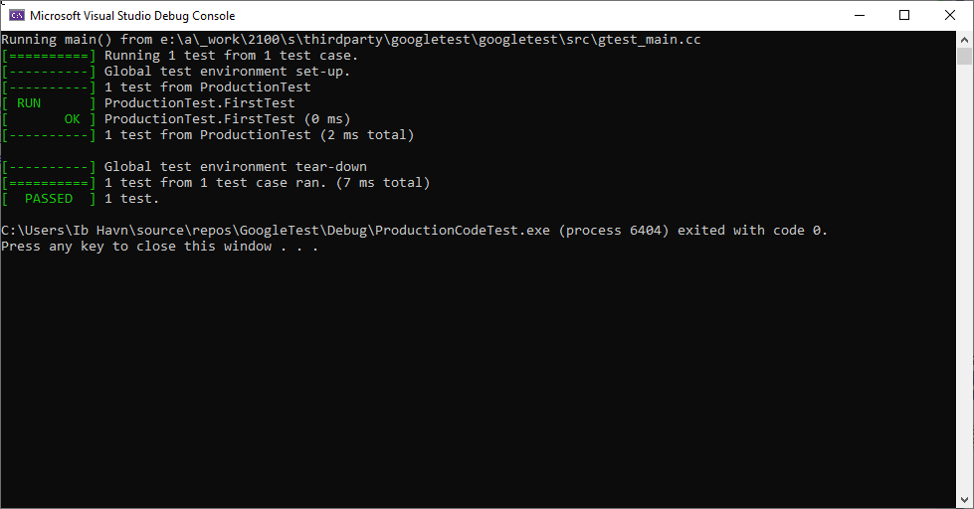

## Disable Precompiled Header

In both the *ProductionCode Project* and the *ProductionCodeTest Project* it is recommended to disable the use of precompiled headers.

Goto *Properties* of **both projects** and set *Precompiled Header* to *Not Using Precompiled Headers* as shown here

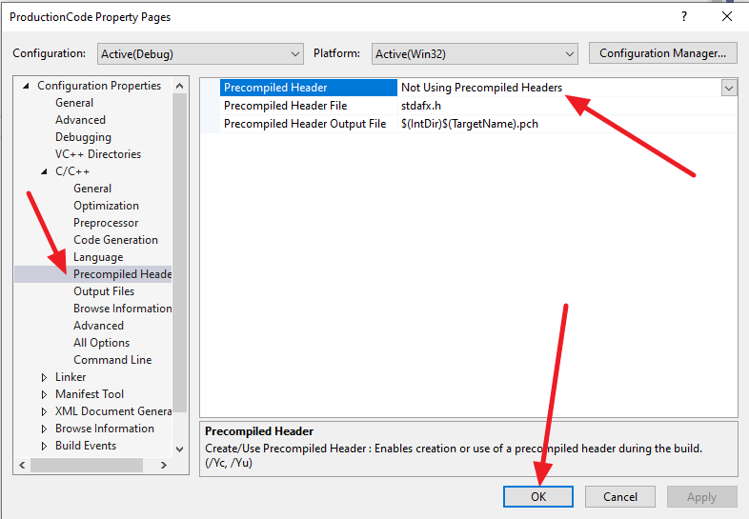

Change the include files from *#include "pch.h"* to *#include "gtest/gtest.h"* in the test source file *productionTest.cpp*.

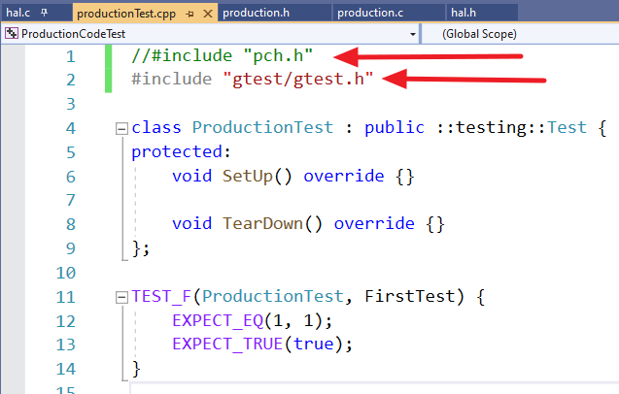

Remove *pch.h* and *pch.cpp* from the *ProductionCode Test* project. Select the two files in the *Solution Explorer*, Right Click and *Exclude From Build*.

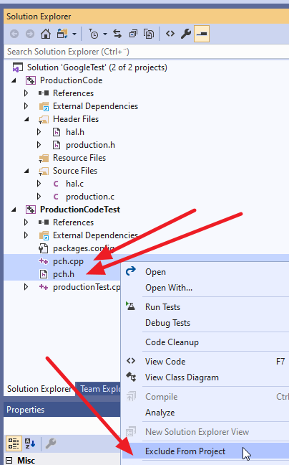

Then clean and rebuild the solution.

## Disable Build of Production Code Project

**Note: Disabling build of Production Code Project is only needed if the production code project is in the same solution as the test project.**

Before it can be executed in the build in *Test Explorer* we will disable building of the production code project – that will allow us to have bugs in part of the production code and still be able to test.

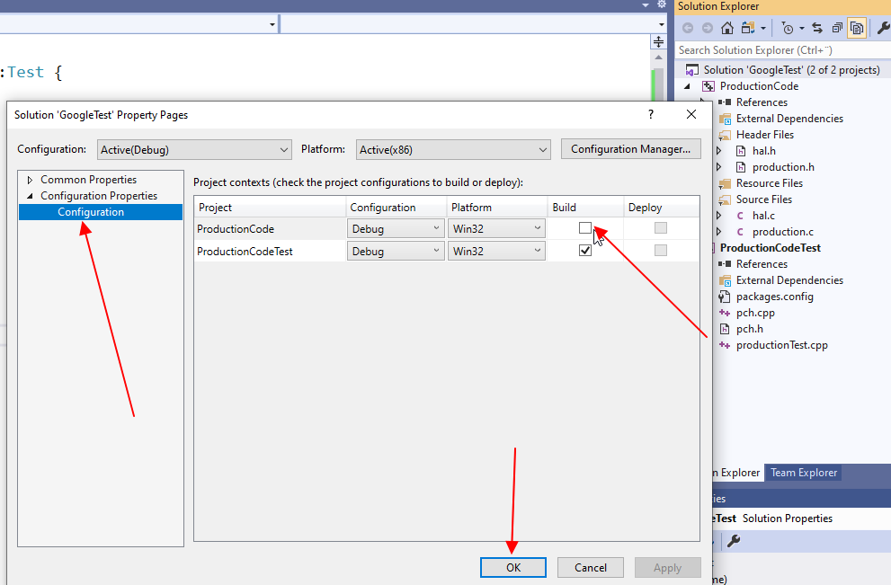

## Running Tests with Test Explorer

Now it is possible to use the *Test Explorer* in Visual Studio.

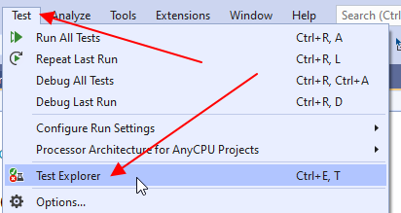

Run all test and it should be possible to see this:

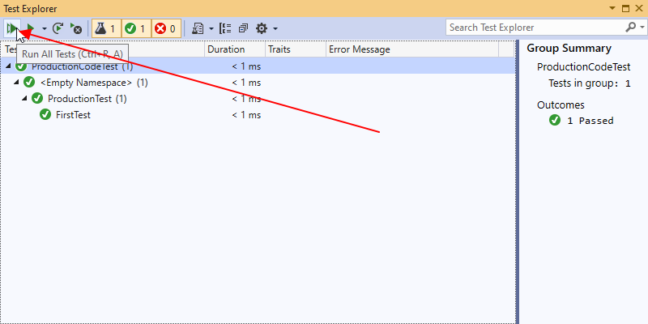

## Mocking

Here we will use the *Fake Function Framework (fff)*[1] for C. This framework is easy to use and consists of a single header file (*fff.h*) to be include in our Test project.

This framework as a very good documentation and can automatically generate mocks for functions in the production code.

### A small Mock example

Figure 1 Class Diagram over a simple example

In the small example seen in Figure 1 we should implement the Production part. The figure includes a Hardware Abstraction Layer (*HAL*) that somebody else will implement but they are not ready yet. We have only access to the interface but not the implementation (*HALImpl*).

Can we implement our part (*Production*) and be sure that it works? Yes, we can! The answer is mocking.

First, we will design how our *ProductionImpl* will interact with the HAL.

Figure 2 Sequence Diagram showing interaction with the HAL.

From Figure 2 we can see what we must test in our *ProductionImpl*. To be able to test that *ProductionsImpl’s* *create()* calls create(10) in *HAL*, here we need to mock out *HALImpl* since we have no access to it.

Let’s see how this can be done.

### Include FFF in Test Project

Clone or download FFF from <https://github.com/meekrosoft/fff>

Include “fff.h” in the test project from where it is located on your computer.

Use the macro *DEFINE_FFF_GLOBALS* to setup the FFF framework.

Include the header files *hal.h* and *production.h* to make the test file able to know the functions defined in these files. Remember *extern “C” {}* around them because they are implemented in C and not C++.

The start of the test file (*ProductionTest.cpp*) must now looks like this:

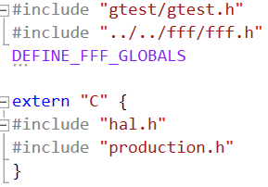

Now we are ready to make a mock for the HAL functions



This is done by using the macros *FAKE_xxx_FUNC* from FFF. The *xxx* must be substituted with return kind of the function.

The mocks for the above two functions are generated with these macro calls:

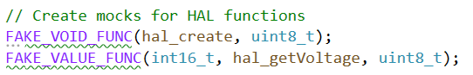

*hal_create* is a void function so *FAKE_VOID_FUNC* is used, the first argument is the name of the function (*hal_create*) and the second argument is the type of the first parameter (*uint8_t*) the function will take.

*hal_voltage* function is returning a value so *FAKE_VALUE_FUNC* is used, the first argument is the return type for the function (*int16_t*) the second argument is the name of the function (*hal_voltage*) and the third argument is the type of the first parameter (*uint8_t*) the function will take.

That is all it takes to create mock functions 😊

Before each test is executed it is necessary to reset the mocks, this is done by calling the *RESET_FAKE* macro on each mocked function. It is also necessary to reset the call history by calling *FFF_RESET_HISTORY* macro. These macros is typically called in the *Setup()* function in the test class.

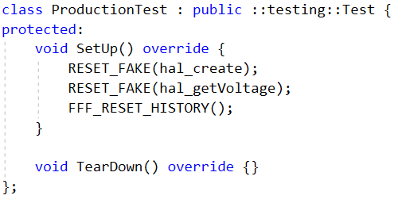

Now the real functions are mocked, and the mock functions are ready to be used.

The mock functions are prefixed width *_fake* so that *hal_create* is mocked to *hal_create_fake*.

### Using Mocked functions in Test cases

We would like to test that *production_create()* will call *hal_create(10)* when *production_create()* is called as seen in the SD:

The following test case will test that

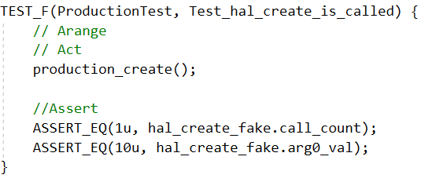

There is nothing to *Arrange* for this test, the *Act* section calls the *production_create()* function.

In the *Assert* section we check that the *hal_create* (*hall_create_fake*) has been called exactly once *ASSERT_EQ(1u, hal_create_fake.call_count)*. And that it was called with the argument *10* as the first argument (*arg0_val*) *ASSERT_EQ(10u, hal_create_fake.arg0_val)*.

We will now test that a call to *production_meassureTemperature(12)* will call *hal_getVoltage(12)* we will also fake that *hal_getVoltage(12)* will return *15* and that a call to *production_getTemperature(12)* will return *30* as seen in the design SD:

The following test case will test that

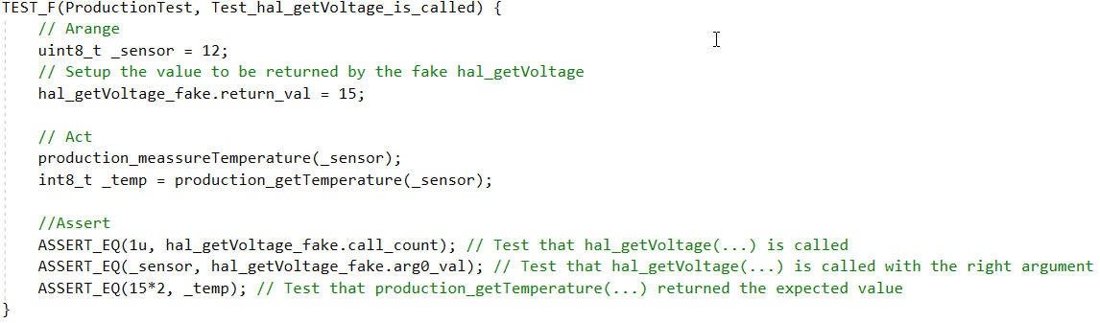

In *Arrange* for this test, the tell the fake *hal_getVoltage* that it should return *15* when it is called *hal_getVoltage_fake.return_val = 15*.

In *Act* we call *production_meassureTemperature(12)* and *production_getTemperature(12)*.

In the *Assert* section we check that the *hal_getVoltage* (*hall_getVoltage_fake*) has been called exactly once *ASSERT_EQ(1u, hal_getVoltage_fake.call_count)*.   
And that it was called with the argument *12* as the first argument (*arg0_val*) *ASSERT_EQ(10u, hal_getVoltage_fake.arg0_val)*.  
Finally we check that the value returned from *production_getTemperature(12)* was *15*2* *ASSERT_EQ(15*2, _temp).*

The result looks like this if the test project is executed normally:

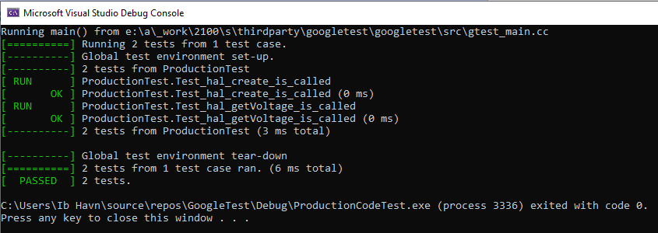

And like this if it is executed with the *Test Explorer* in Visual Studio:

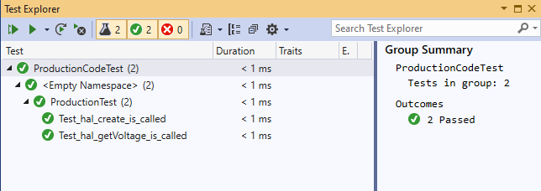

# GitHub

All can be found in <https://github.com/ihavn/GoogleTestDemo>

1. <https://github.com/meekrosoft/fff>